Financial Data ARIMA Model(Gaussian Processes)

AR(Autocorrelation),I(Integerated),MA(Moving Average)

ACF(Autocorrelation) (P=2)

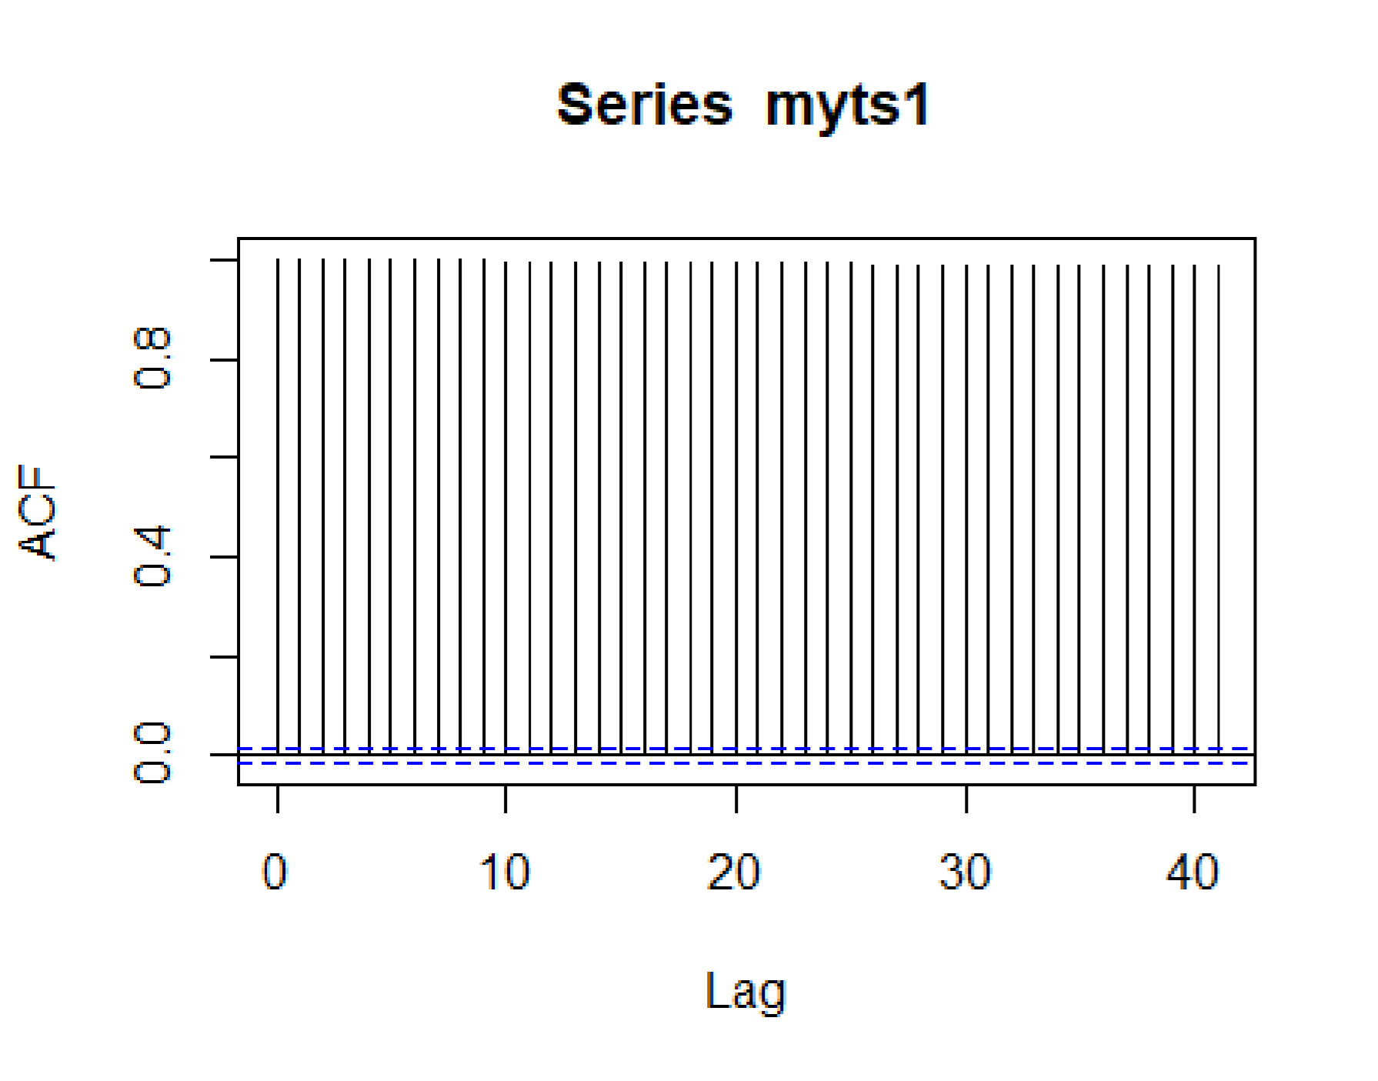

PCF(Partial Autocorrelation)(Q=2)

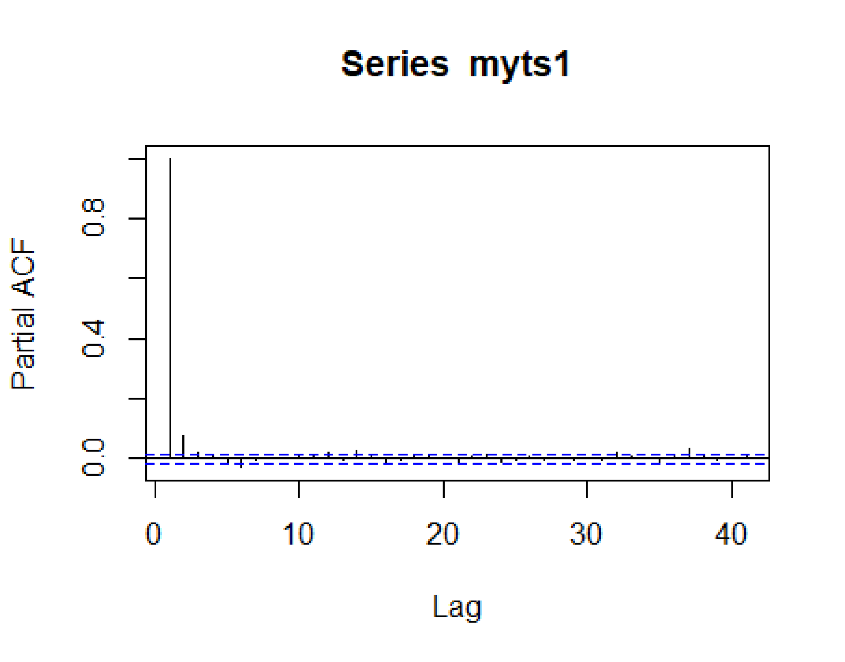

I(Integerated)(D=1)

Find the value of D to check data is stationary or non-stationary If data is stationary then value will be 0 but if is non stationary then it will have some value to make data stationary

**Result of Arima Model**

Series: myts1

ARIMA(2,1,2) with drift

Coefficients:

ar1 ar2 ma1 ma2 drift 0.9920 -0.4339 -1.1074 0.5093 0 s.e. 0.0902 0.0538 0.0884 0.0547 0 sigma^2 estimated as 5.985e-10: log likelihood=133891

AIC=-267769.9 AICc=-267769.9 BIC=-267724.4

Mean Absolute Percentage Error(MAPE)->0.0006435241

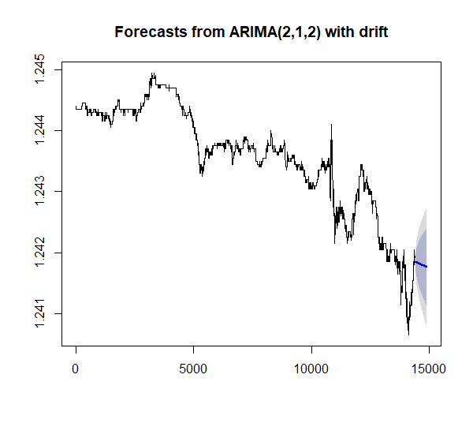

**Model with drift term captures the downward trend**

Forecast Lo 80 Hi 80 Lo 95 Hi 95

14401 1.241849 1.241817 1.241880 1.241801 1.241897

14402 1.241849 1.241807 1.241890 1.241785 1.241913

14403 1.241849 1.241799 1.241898 1.241773 1.241925

14404 1.241849 1.241793 1.241905 1.241763 1.241935

14405 1.241849 1.241786 1.241912 1.241753 1.241945

14406 1.241849 1.241780 1.241918 1.241744 1.241955

14407 1.241849 1.241774 1.241924 1.241734 1.241963

14408 1.241849 1.241768 1.241929 1.241726 1.241971

14409 1.241848 1.241763 1.241933 1.241718 1.241978

14410 1.241848 1.241758 1.241938 1.241711 1.241985

**Parameters of the model will affect performance if changed**

Performance of the model depends upon three parameters

1. Autocorrelation

2. Partial Autocorrelation

3. Integrated

If we will change values of these manually then performance of the model vary a lot so that’s why we use auto Arima for letting model decide itself the best values of these three.